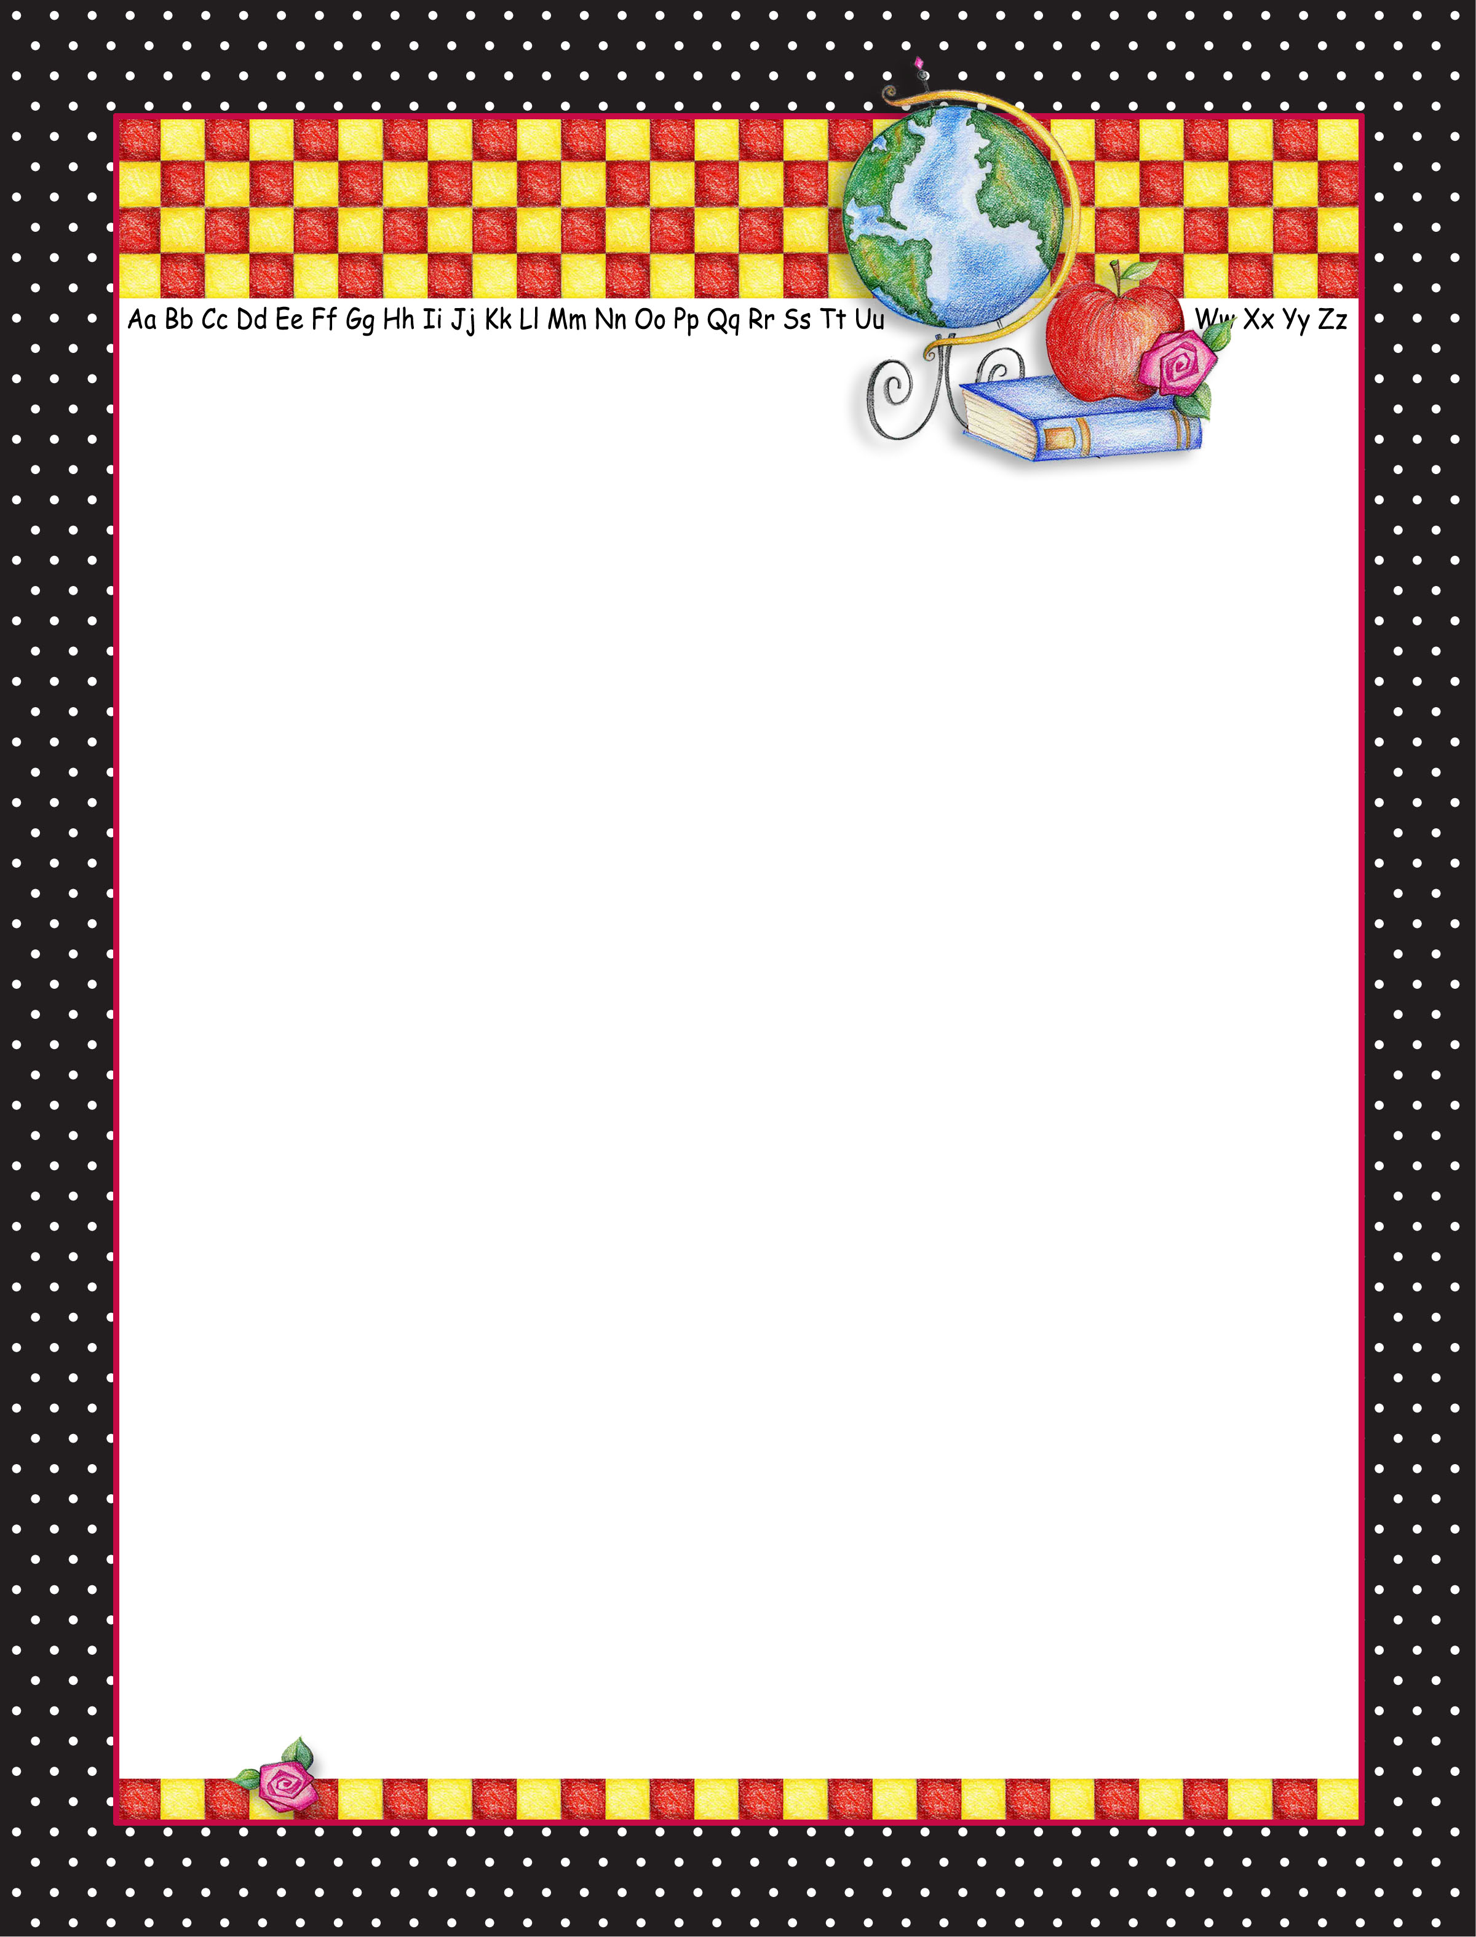
Use this template to create colorful notes, supply or
reminder lists, classroom notices, teacher stationery…let your imagination run free.

