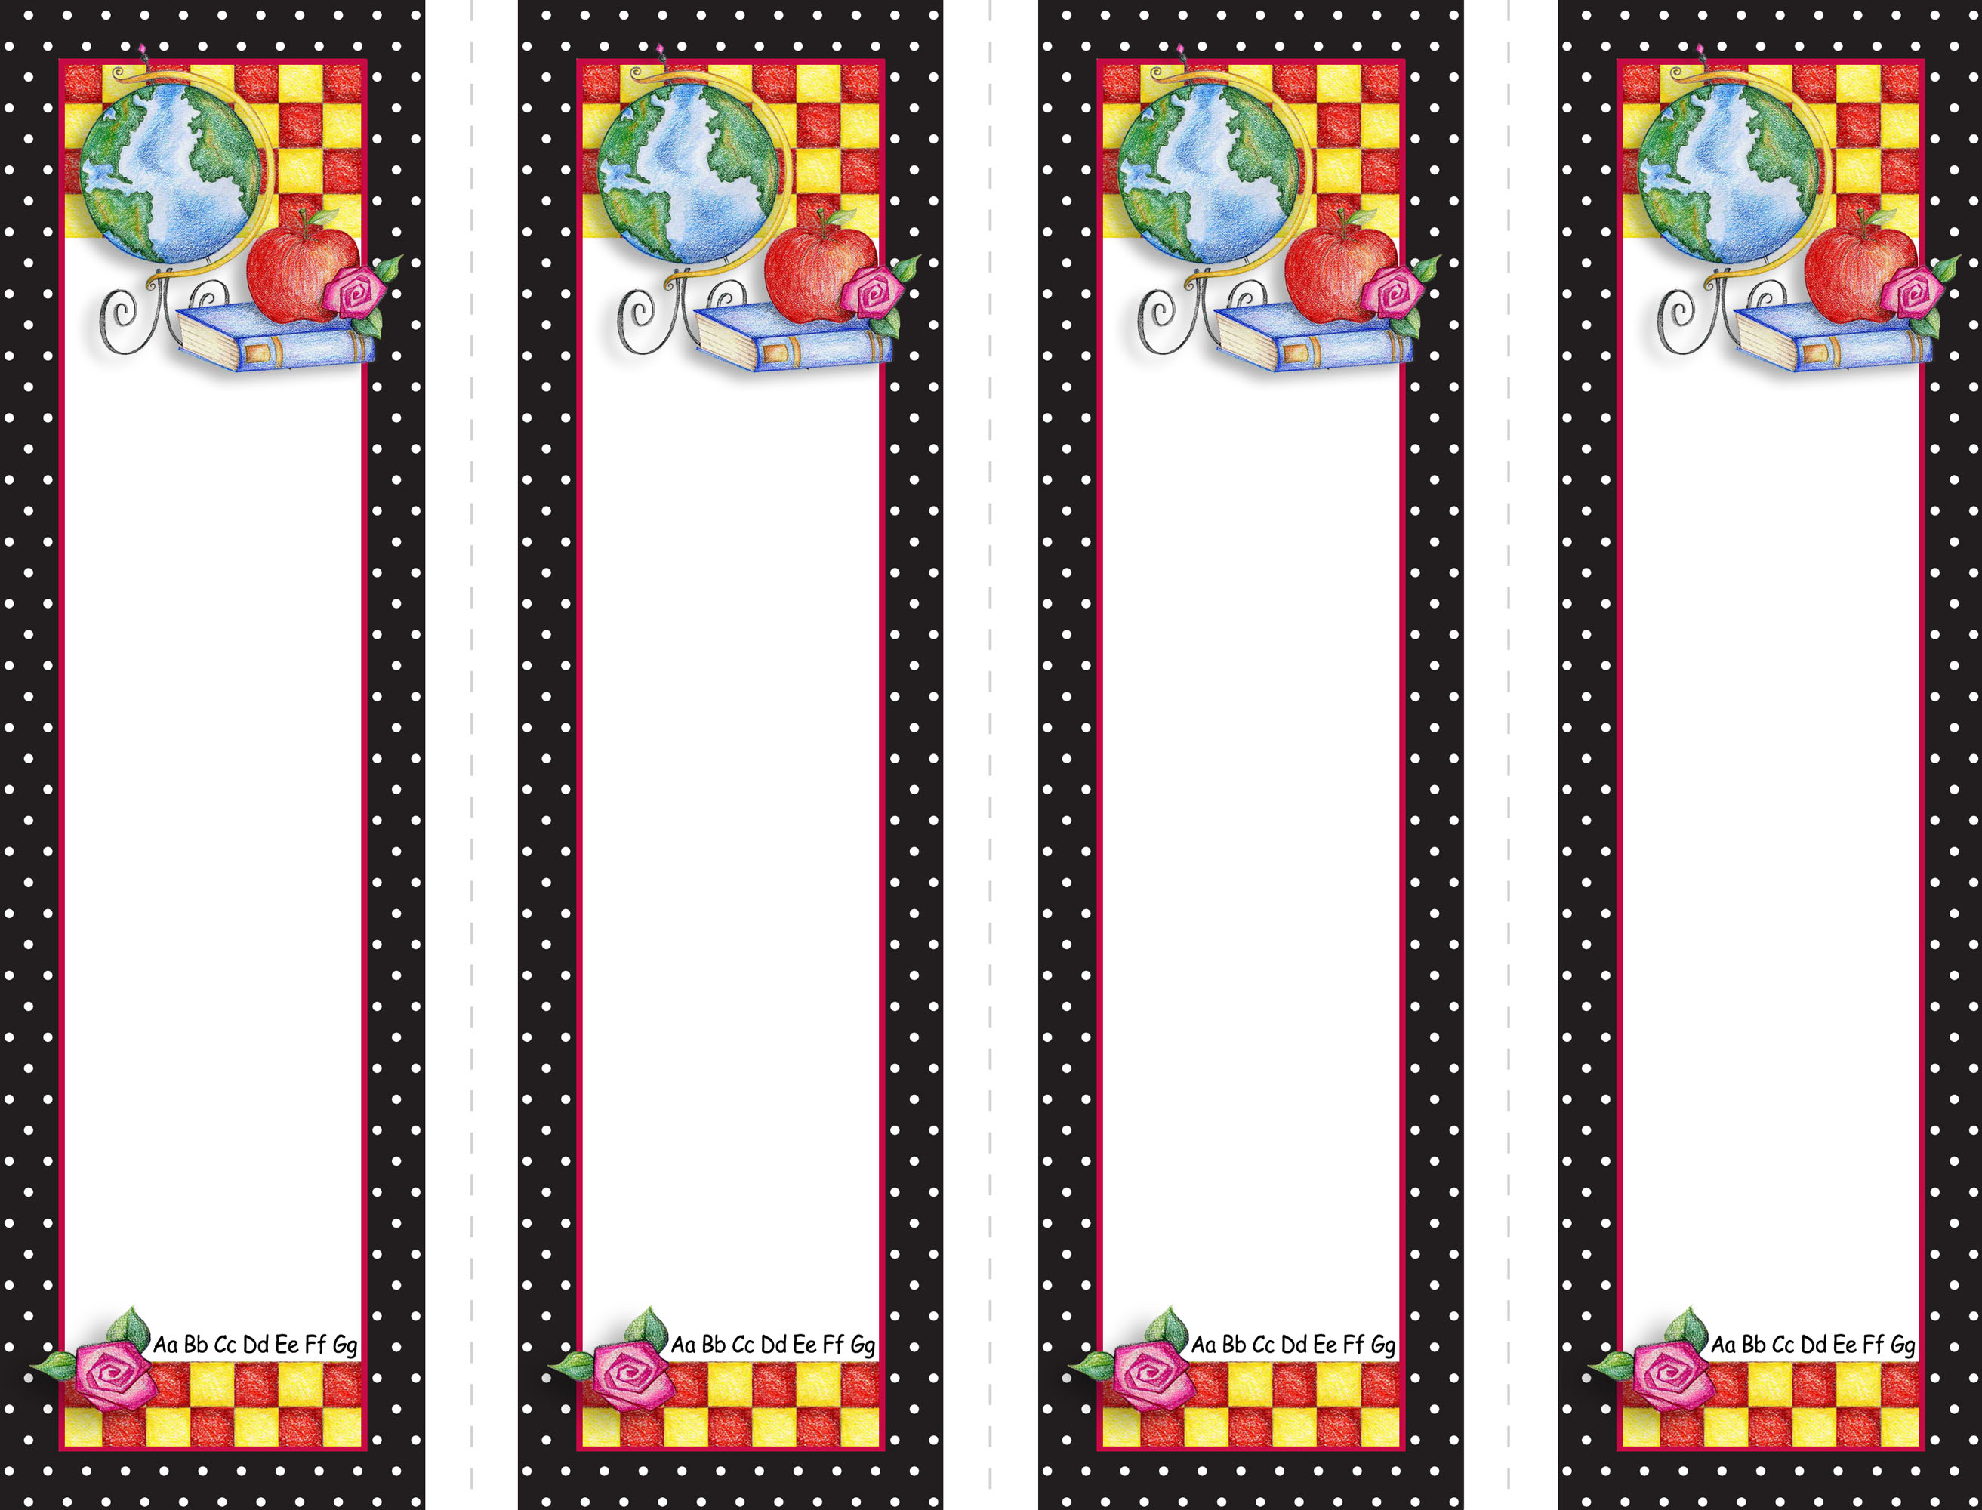


Double-Click

on “Name Here” text

to customize.

Click here
to insert
optional text
such as a quote from assigned reading.
Or, add lines for student use.

YOUR LOGO HERE IF DESIRED

Double-Click

on “Name Here” text

to customize.

Click here
to insert
optional text
such as a quote from assigned reading.
Or, add lines for student use.

Double-Click

on “Name Here” text

to customize.

Click here
to insert
optional text
such as a quote from assigned reading.
Or, add lines for student use.

Double-Click

on “Name Here” text

to customize.

Click here
to insert
optional text
such as a quote from assigned reading.
Or, add lines for student use.

