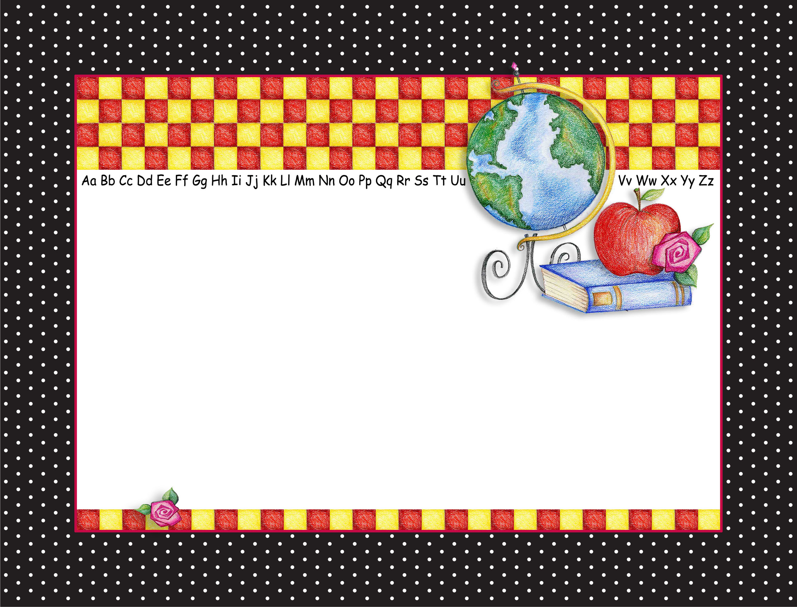


Jason Riley

Has achieved excellence in the

Multiplication Tables

Signed: __________________________________ Date: ________________

YOUR LOGO HERE IF DESIRED
Double-Click on “Award of Excellence” text to customize.

