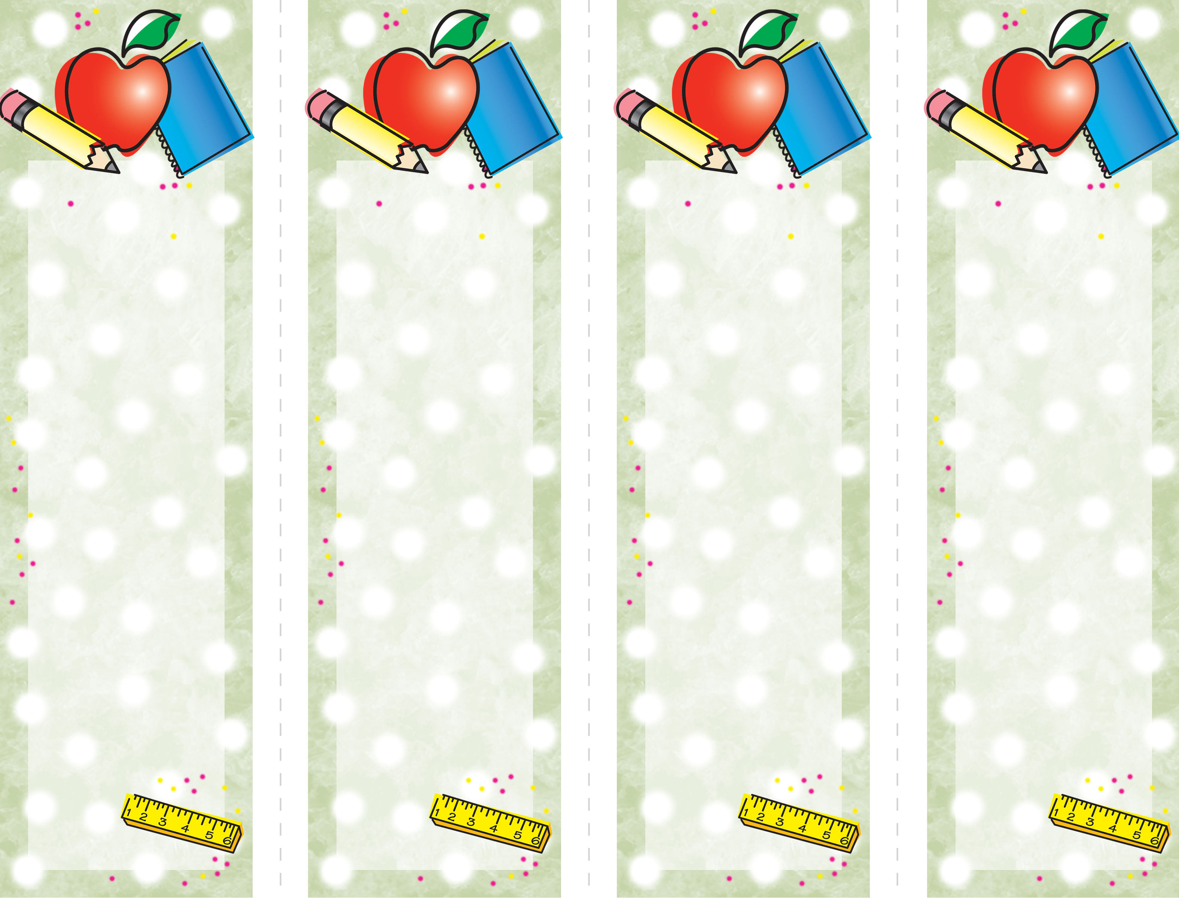

Double-Click

on “Name Here” text

to customize.

Click here
to insert
optional text.

YOUR LOGO HERE IF DESIRED

Double-Click

on “Name Here” text

to customize.

Click here
to insert
optional text.

Double-Click

on “Name Here” text

to customize.

Click here
to insert
optional text.

Double-Click

on “Name Here” text

to customize.

Click here
to insert
optional text.

