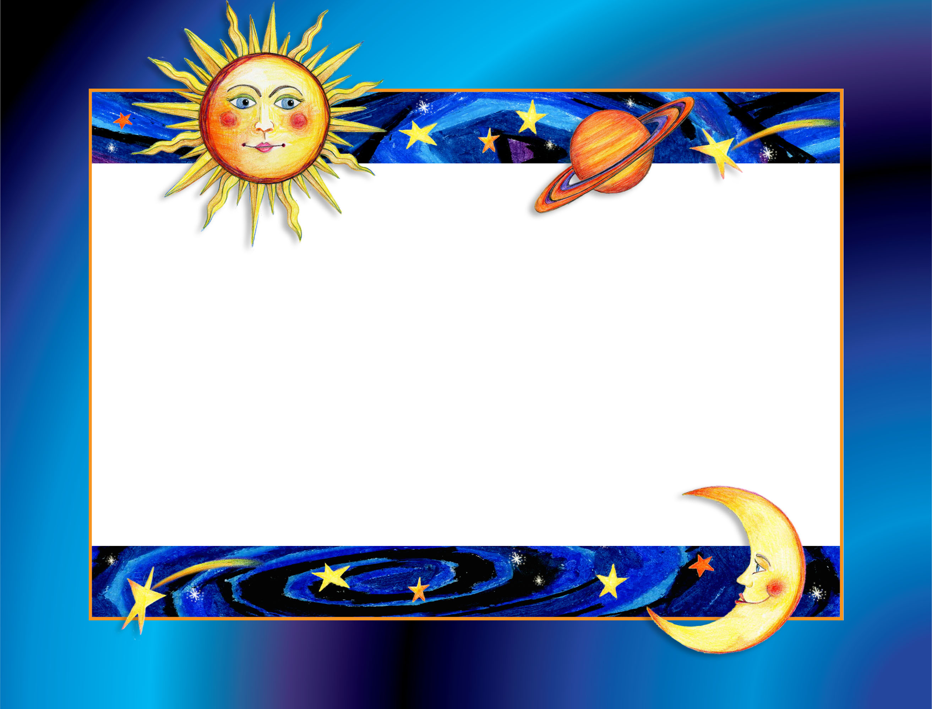

Scott Mathews

Has successfully completed the course

Exploring Our Universe

Signed: __________________________________ Date: ________________

YOUR LOGO HERE IF DESIRED
Double-Click on “Certificate of Achievement” text to customize.

