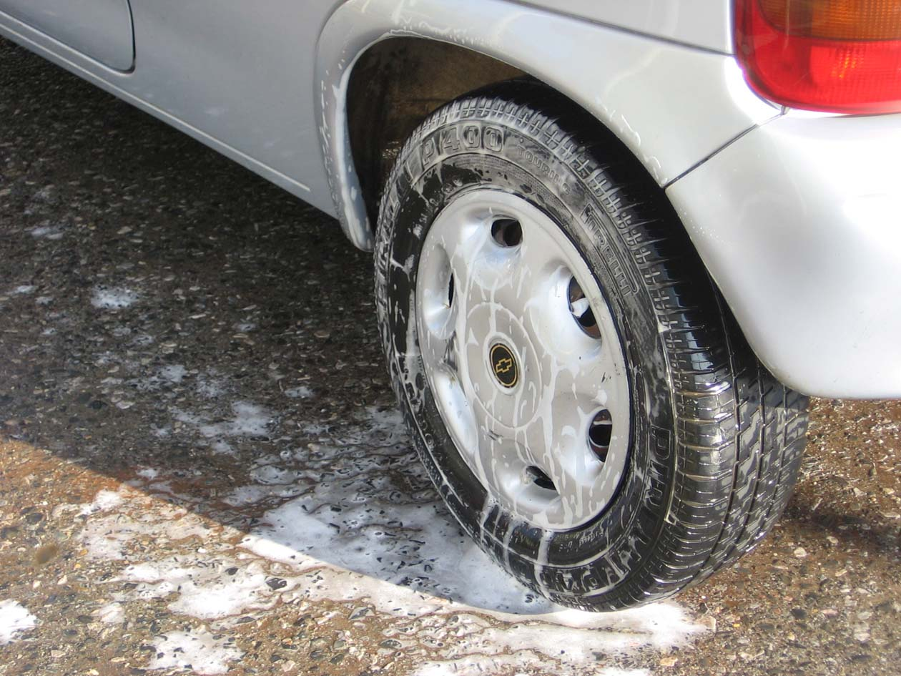
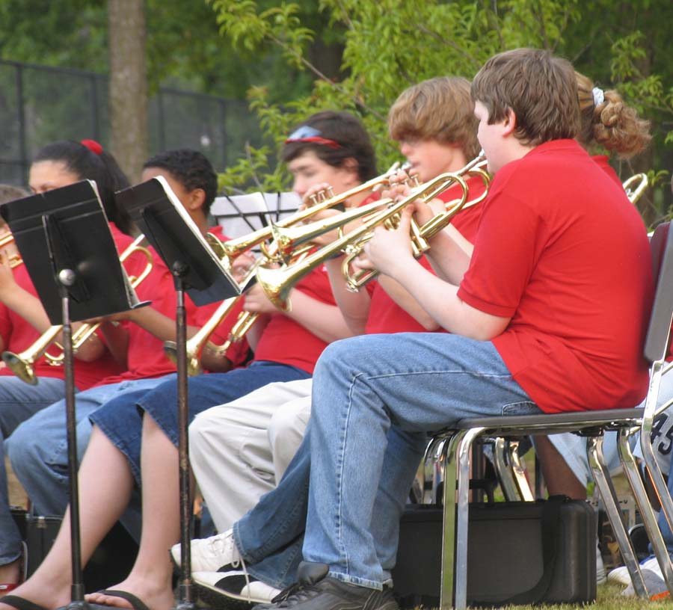
DON’T MISS This Fantastic,
Awesome, Opportunity
To Shine!
(And you’ll be doing it all for your kids.)
ATHLETICS
OUTDOOR SCHOOL
BAND/MUSIC
YourTown Elementary 3rd Annual
CAR WASH
Sept. 25
Noon-7pm
$3.00 per car
Please make a point to join us for a splashing-good-time…and get your car clean to boot! Students, Teachers and Parents alike are all lending a hand (and sponge) to help make this fundraising event a success.
WHERE: Sam’s Grocery, Fifth & Main
WHEN: Noon–7pm, Saturday September 25
HOW MUCH: $3.00 per car

2006-2007
Fundraising Goals:

Band/Music Department -
Sheet Music
Drum sticks (2 pair)
Piano Bench
12 Music Stands

Athletic Department -
½ Insurance Premium
12 Football Helmets
24 Softballs
4 Softball Bats
6 Playground Balls

Outdoor School -
The District will match funds for 6th Grade Outdoor School. The cost is approx. $68 per student.

2006-07 Goal:
$6,000

$4,000

$2,000

Car Wash:
$1,000

