
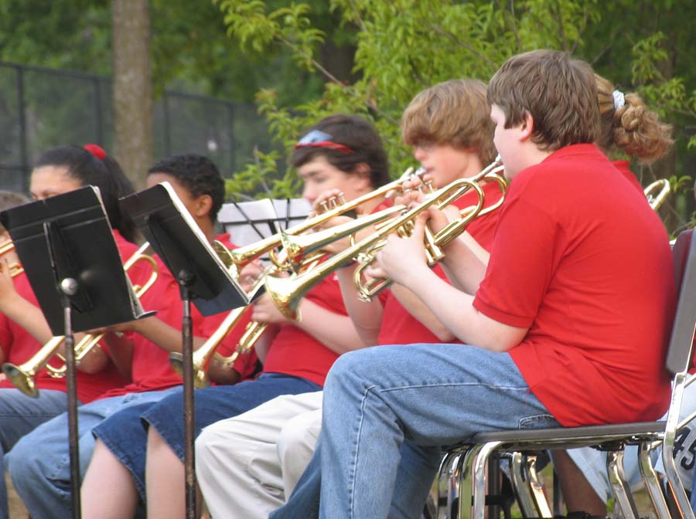
ATHLETICS
OUTDOOR SCHOOL
BAND/MUSIC
YourTown Elementary 3rd Annual
BAKE SALE
DON’T MISS This Delicious,
Mouth-Watering,
Excuse to Splurge!
(And you’ll be doing it all for your kids.)
Sept. 25
Noon-4pm
HERE’S ALL YOU DO...
- Bring your favorite baked goods to the YourTown Elementary Cafeteria by 9:00am, September 25. We’ll do all the pricing, display and packaging. That means if you want to bring us a box with 18 dozen cookies we’ll package by the dozen or mix with your neighbors for a variety. Whole Cakes & Pies only please.
- Come back between Noon and 5pm to indulge. Satisfy your sweet tooth or fill the freezer with treats for the Holidays…it’s all for the kids!
- Tell your friends and neighbors, nobody wants to miss out on Principal Joe’s famous Apple Turnovers.
2006-2007
Fundraising Goals:

Band/Music Department -
Sheet Music
Drum sticks (2 pair)
Piano Bench
12 Music Stands

Athletic Department -
½ Insurance Premium
12 Football Helmets
24 Softballs
4 Softball Bats
6 Playground Balls

Outdoor School -
The District will match funds for 6th Grade Outdoor School. The cost is approx. $68 per student.

2006-07 Goal:
$24,000

$18,000

$12,000

Bake Sale:
$6,000

