
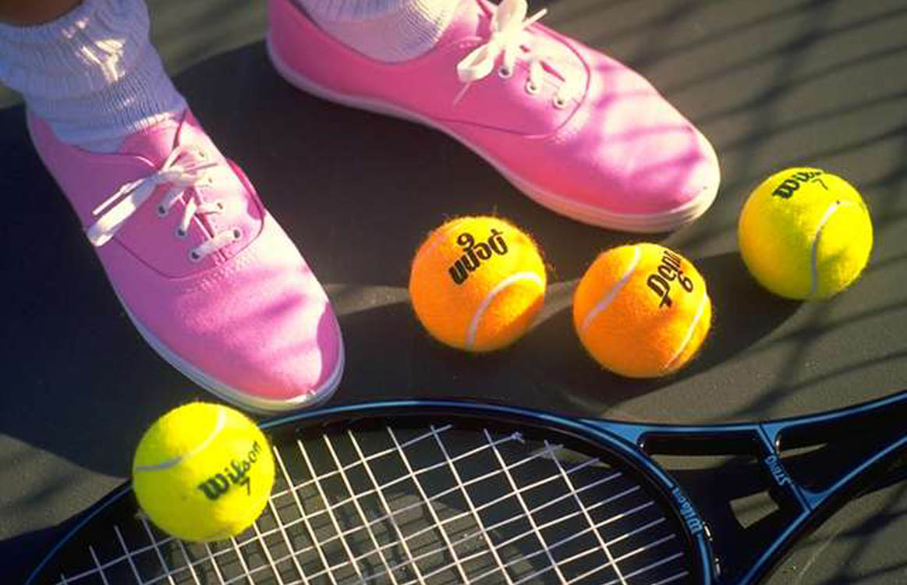
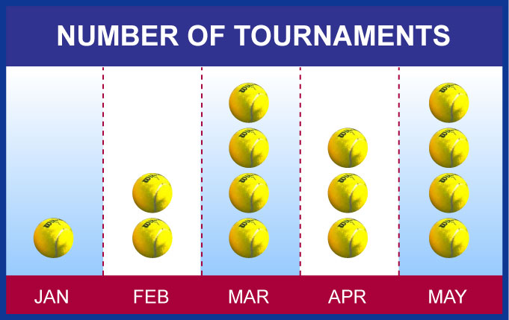
the colors. These flyer templates
are very versatile and can be
customized to fit your needs. Insert
your own photographs, text, logos and artwork…even change the colors. These flyer templates are very versatile and can be customized to fit your needs. Insert your own photographs, text, logos and artwork…even change the colors.

- Bullet point to go here, may be single or multiple lines of copy.
- Bullet point to go here, may be single or multiple lines of copy.
- Bullet point to go here, may be single or multiple lines of copy.
- Bullet point to go here, may be single or multiple lines of copy.

POSITIONING STATEMENT HERE

MAY BE MULTIPLE LINES
Place a subhead or intro copy here

HEADLINE
These flyer templates are very versatile and can be customized to fit your needs. Insert your own photographs, text, logos and artwork…even change the colors. These flyer templates are very versatile and can be customized to fit your needs. Insert your own photographs, text, logos and artwork…even change the colors. These flyer templates are very versatile and can be customized to fit your needs. Insert your own photographs, text, logos and artwork…even change
“
”
Photo caption or pull quote
to go in this space.

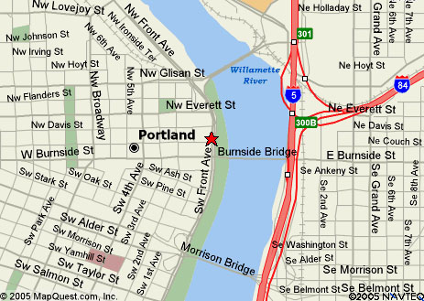
A description of product or service
OFFER/SAVINGS
Additional copy in this space
Your Name/Location/Phone
A description of product or service
OFFER/SAVINGS
Additional copy in this space
Your Name/Location/Phone
A description of product or service
OFFER/SAVINGS
Additional copy in this space
Your Name/Location/Phone
“
”
Photo caption or pull quote
to go in this space.
Place a subhead or intro copy here

These flyer templates are very versatile and can be customized to fit your needs. Insert your own photographs, text, logos and artwork…even change the colors. These flyer templates are very versatile and can be customized to fit your needs. Insert your own photographs, text, logos and artwork…even change the colors. These flyer templates are very versatile and can be customized to fit your needs. Insert your own photographs, text, logos and artwork…even change the colors.

- Bullet point to go here, may be single or multiple lines of copy.
- Bullet point to go here, may be single or multiple lines of copy.
- Bullet point to go here, may be single or multiple lines of copy.
- Bullet point to go here, may be single or multiple lines of copy.

Your Name/Logo Here
(800) 555-1212
Address • City • State • Zip Code
www.yourwebaddress.com

OPEN 7 DAYS A WEEK
M-F: 7am – 10pm
Sat: 6am – 11pm
Sun: 9am – 9pm

