


h
eadline

YOUR NAME/LOGO
www.yourwebaddress
These flyer templates are very versatile and can be customized
to fit your needs. Insert your own photographs, text, logos and artwork…even change the colors. These flyer templates are very versatile and can be customized
to fit your needs. Insert your own photographs, text, logos and artwork…even change the colors.


colors.

Subhead in this space

- Optional bullet points here.
- Optional bullet points here.
- Optional bullet points here.
- Optional bullet points here.
- Optional bullet points here.

These flyer templates are very versatile and can be customized
to fit your needs. Insert your own photographs, text, logos and artwork…even change the colors. These flyer templates are very versatile and can be customized
to fit your needs. Insert your own photographs, text, logos and artwork…even change the colors.
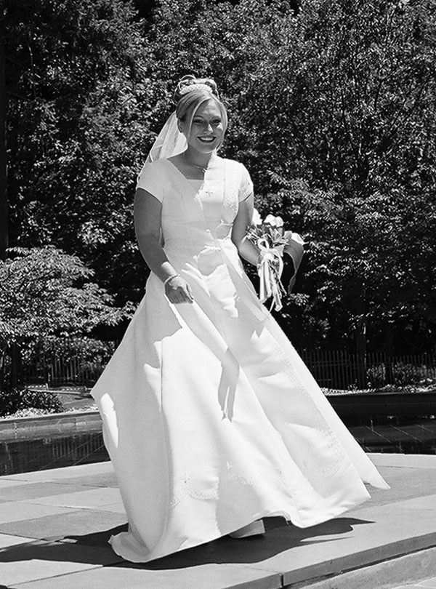
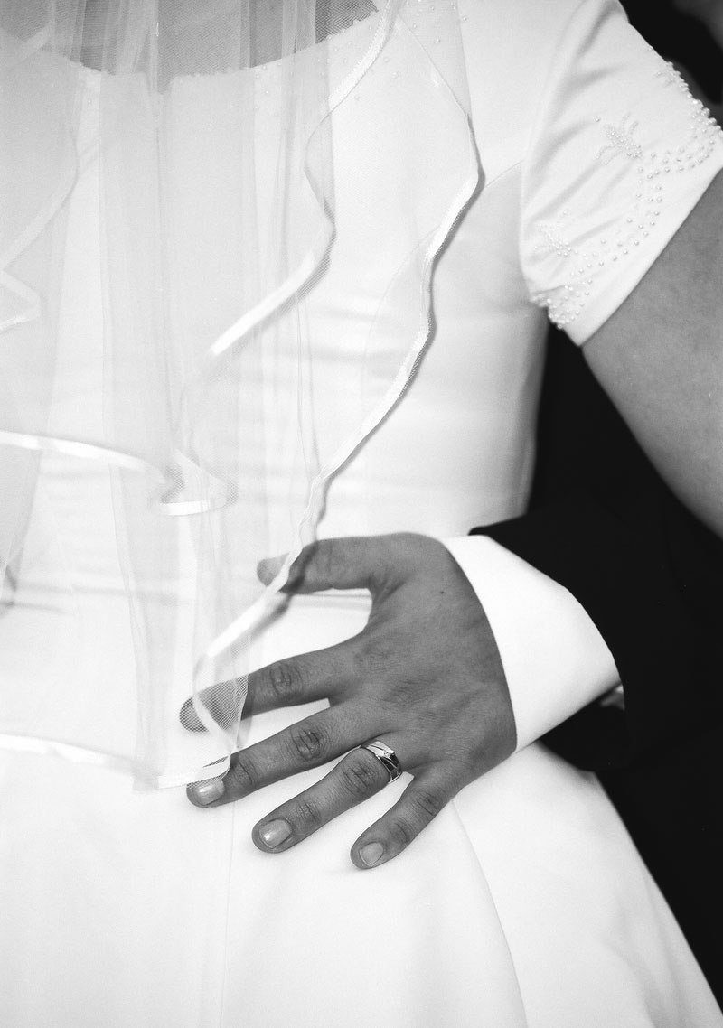

h
eadline

Your Name/Logo

(800) 555-1212
Address • City • State • Zip Code
email@youremail.com
www.yourwebaddress.com

