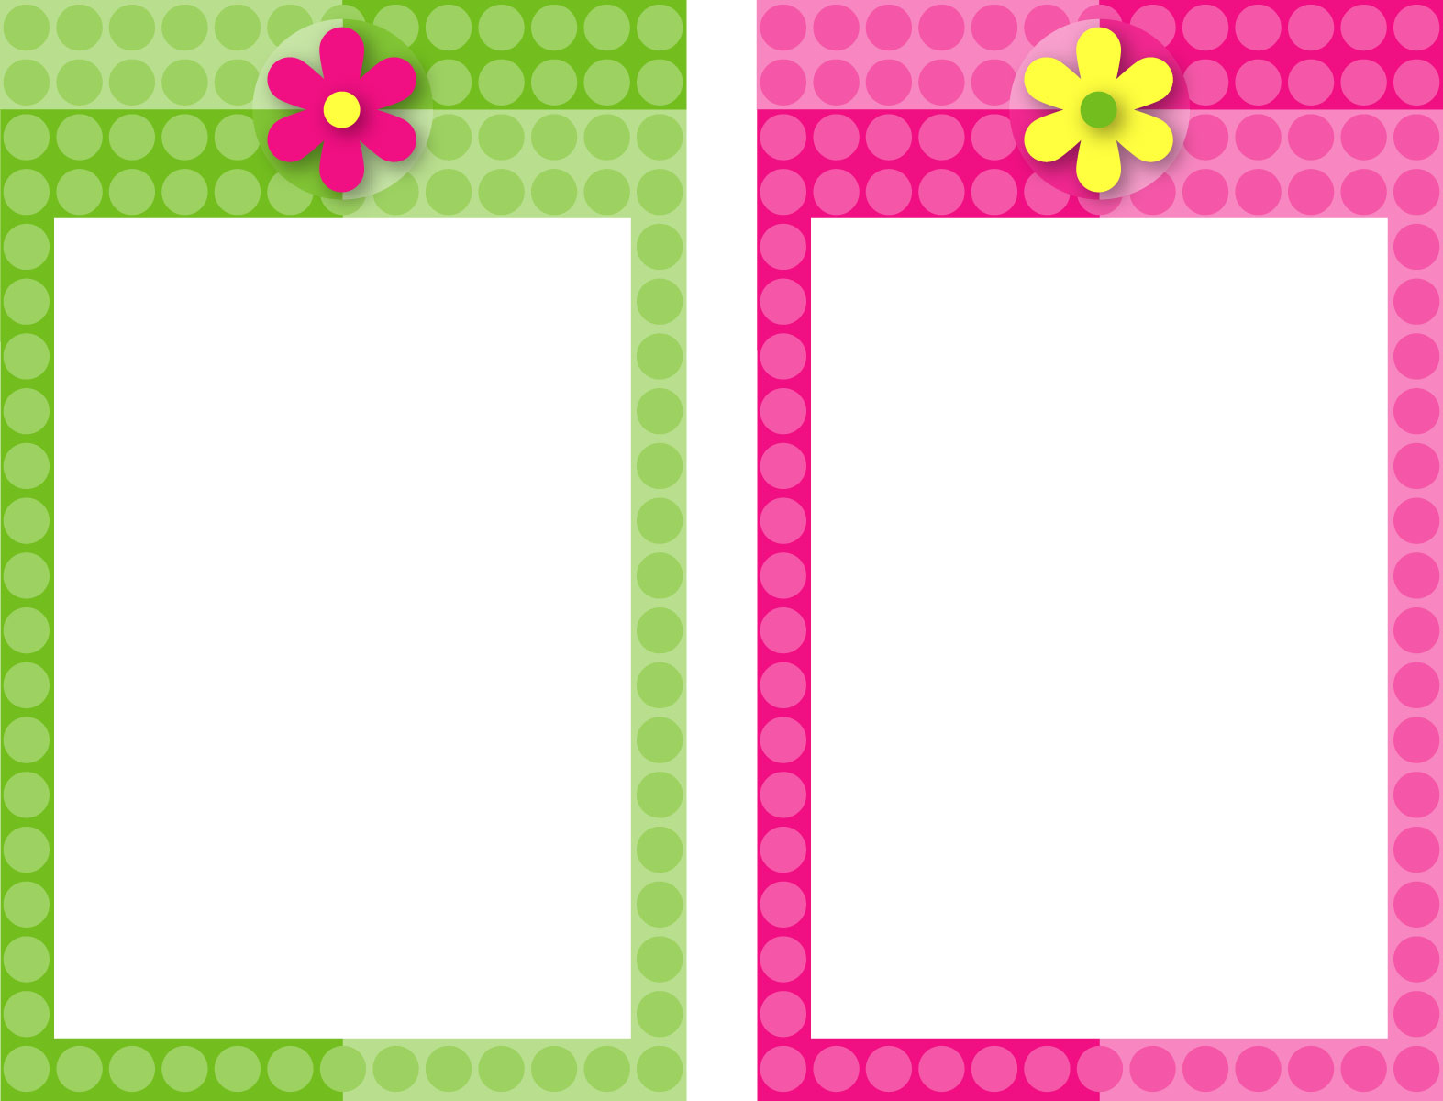

Double-Click on “Reminder!” text to customize.

Click here
to insert
optional text.

Double-Click on “Reminder!” text to customize.

Click here
to insert
optional text.

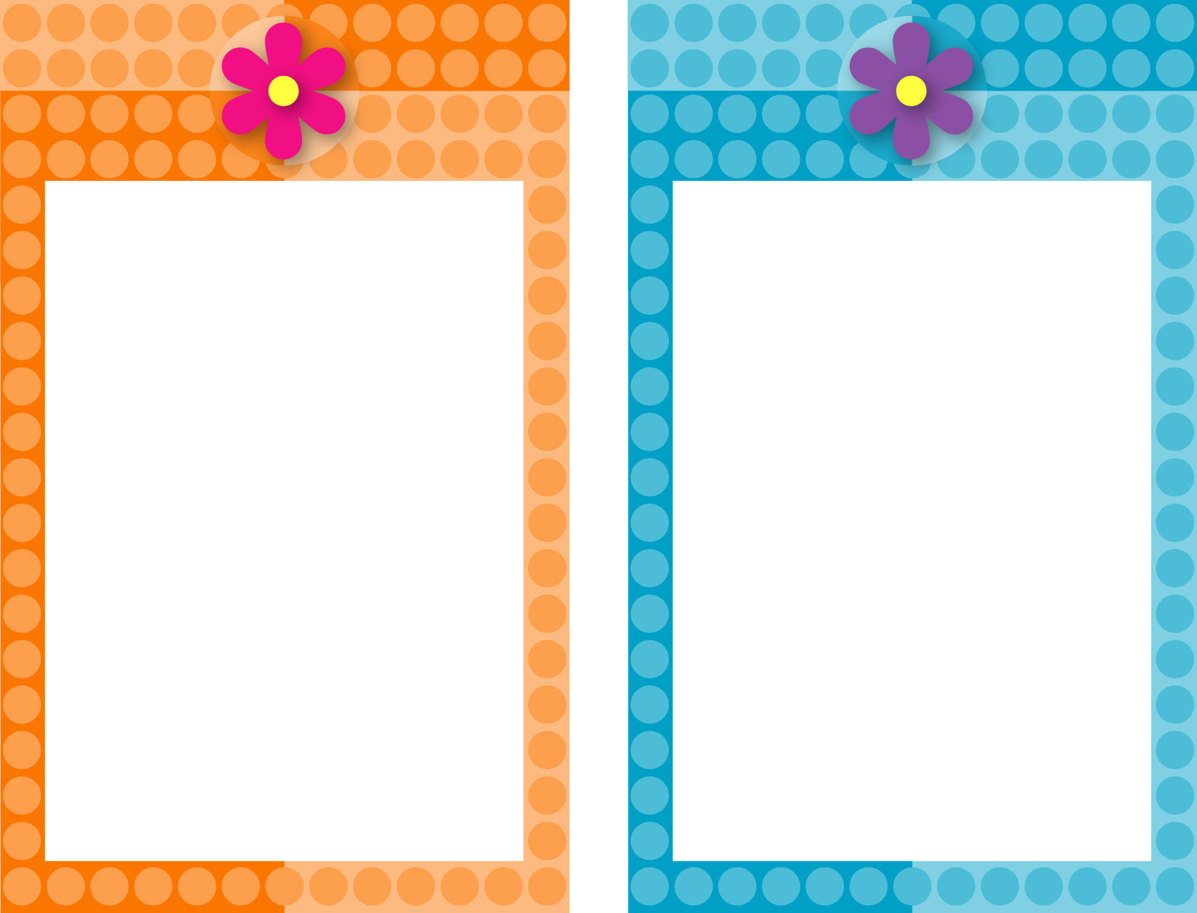

YOUR LOGO HERE IF DESIRED

Double-Click on “Reminder!” text to customize.

Click here
to insert
optional text.

Double-Click on “Reminder!” text to customize.

Click here
to insert
optional text.

