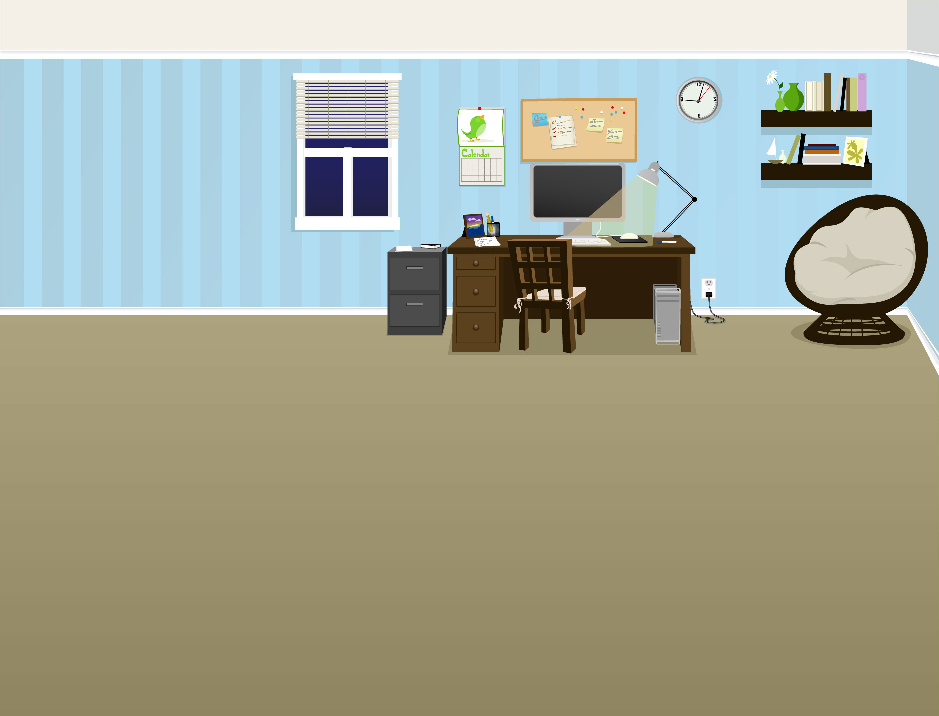
Working remotely today
8-5:30 p.m.
Email, IM or call 888-800-0808

I'll be back in the office tomorrow.

