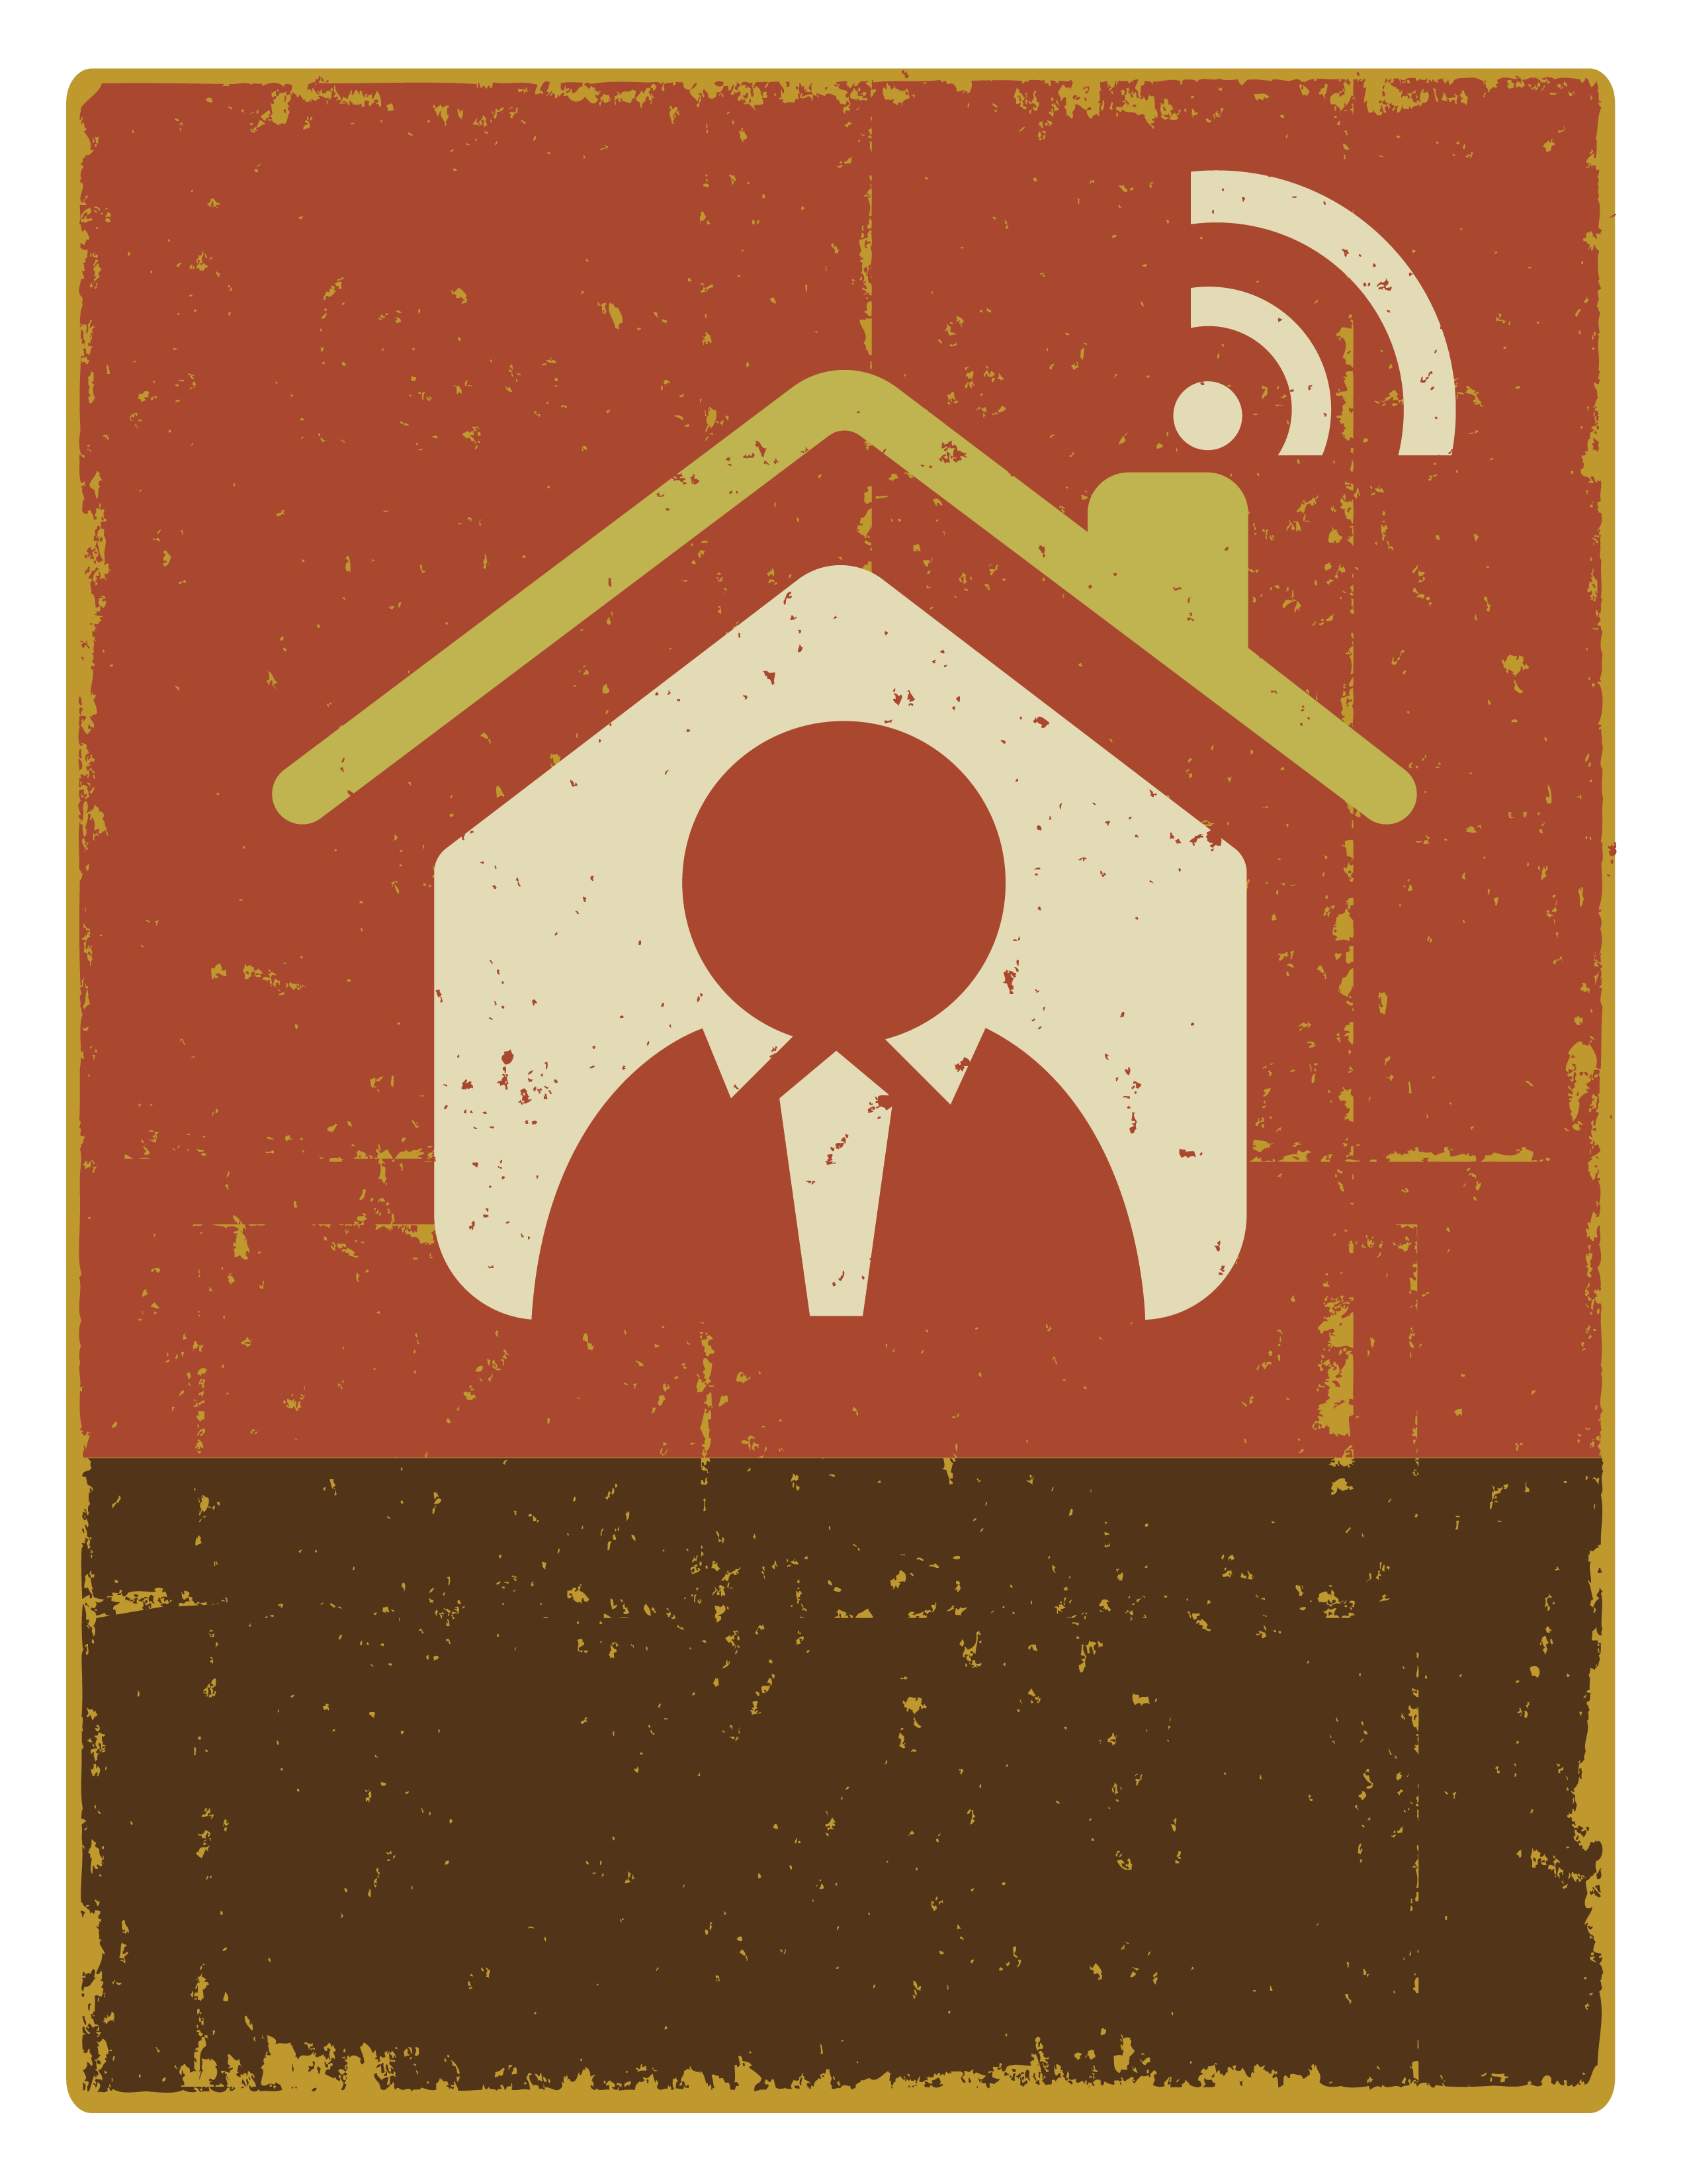
WORKING
FROM HOME
Call or email me

