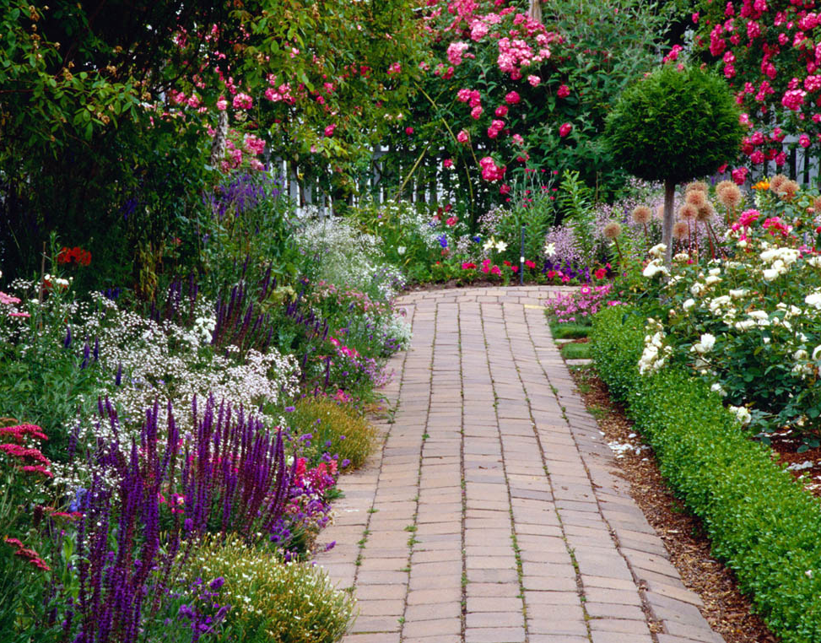
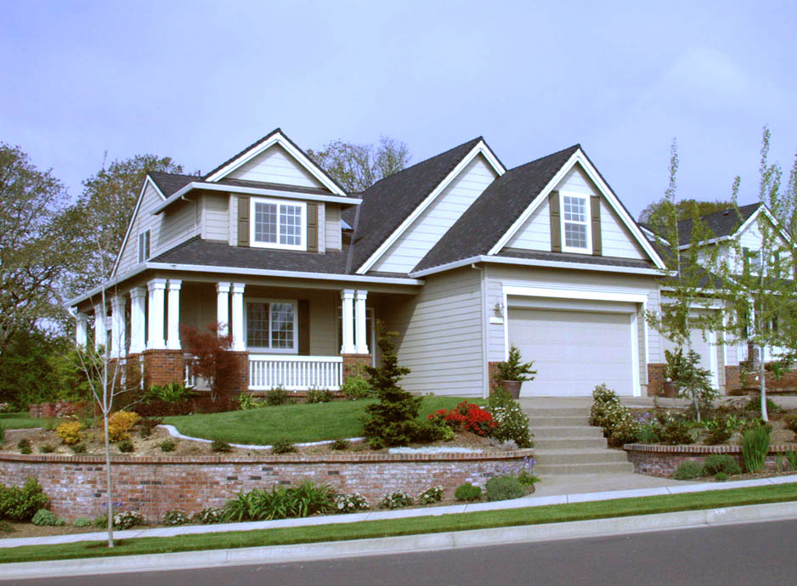
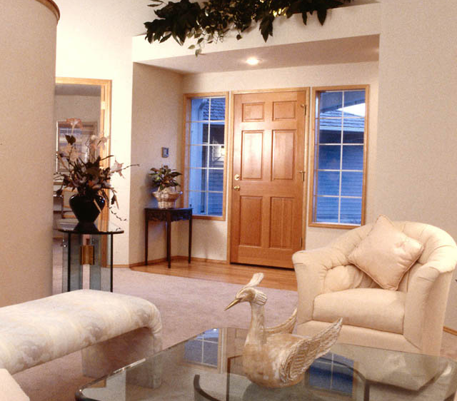
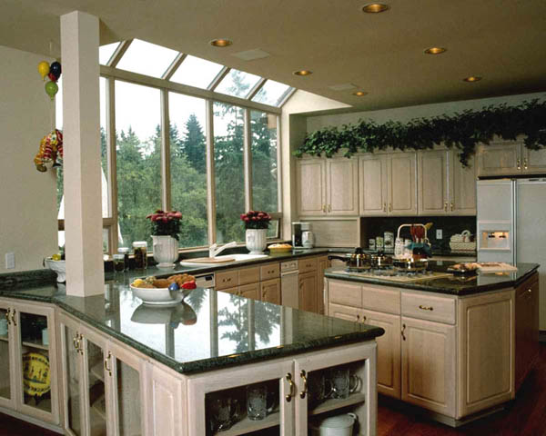
.
Fantastic view, open and airy, you must see it to really appreciate the ambiance and setting. Designed for family living with dramatic open areas and plenty of windows and light. Only minutes from city center, dining and shopping.

Beauty. Stunning Views.

BIG HOME, Little Budget.

10224 SW River Lane • Portland, OR 97231
Don’t let this one pass you by…
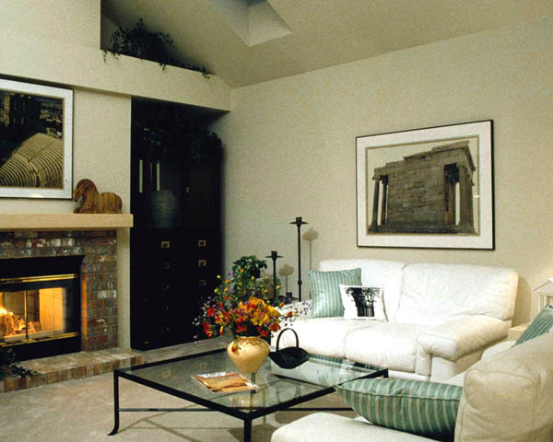
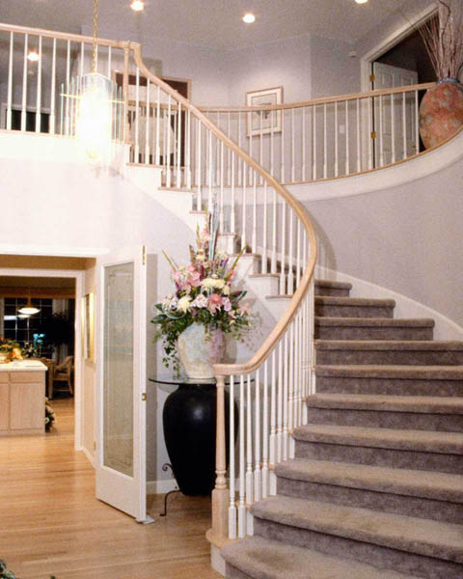
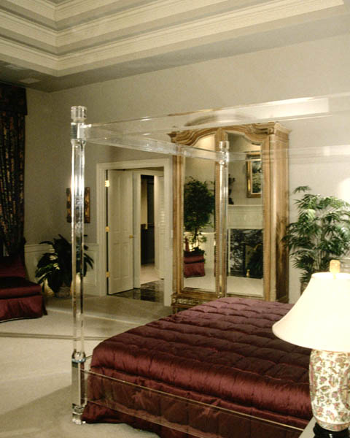
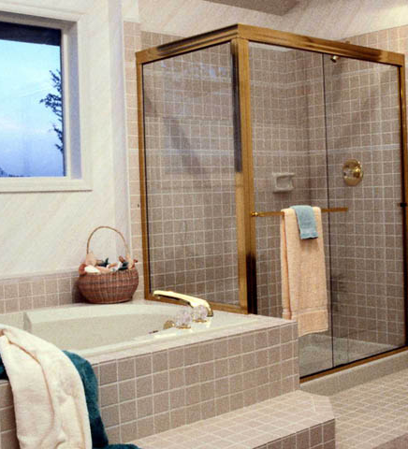
Fabulous space, great location, you must see it to really appreciate the ambiance and setting. Designed for family living with dramatic open areas and plenty of windows and light. Lushly landscaped with Koi pond and perennial gardens. Only 20 minutes from city center and two blocks from Kennedy Elementary School.

- 3200 square feet
- 4 bedrooms, 3.5 bathrooms
- Large, finished basement, perfect for family activities
- Vaulted ceilings
- Hardwood floors with mahogany inlay
- Custom gourmet kitchen with Sub-Zero refrigerator & double ovens
- Granite countertops
- Wood and glass cabinetry
- Formal dining area, custom designed home office space

For a personal showing, please call 800-555-1212
Or experience a virtual tour on our website:

www.yourwebaddress.com

Agent Name
Agent Title

(800) 555-1212 phone 1
(800) 555-1212 phone 2
(800) 555-1212 phone 3
email@youremail.com
www.yourwebaddress.com

LOGO

