
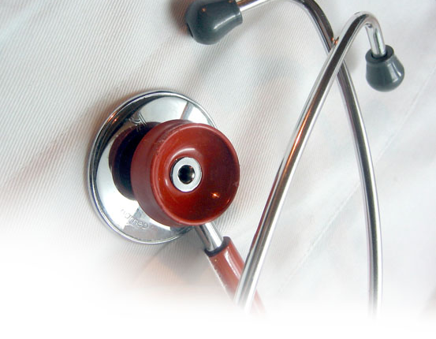
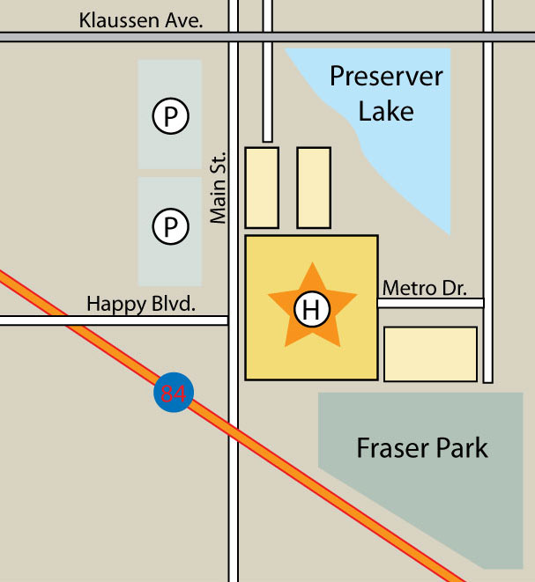

METRO
HEALTH
METROHEALTH
WELCOME
METROHEALTH SERVICES AND OVERVIEW

1000 Main Street
Healthville, USA
www.metrohealth.com
A Brief History

Founded in early 1902, MetroHealth was the first hospital of its kind to focus on “preventative medicine,” and was the only hospital in the tri-city area for more than 50 years. Preventative health is still a primary focus for MetroHealth today, as you will see in the variety of health management programs and high-quality care available to you as a MetroHealth patient.

How to Find Us

MetroHealth is easy to find as well as convenient.
Located centrally with both bus and metro access.
Bus schedule: 1-800-TRIMETBUS
www.TRIMETBUS.org
Metro schedule: 1-800-METROLINE
www.metroschedule.org

Travel by car:
South: Travel
5 mi on 84 West. Exit on Main St. Straight. Right on Klaussen.
North: Travel
5 mi on 84 West. Exit on Main St. Straight. Right on Klaussen.
INFORMATION

QUICK REFERENCE GUIDE TO
METROHEALTH
SERVICES
Simplifying Your Visit

Keep these numbers handy—you’ll need them for your next MetroHealth visit or prescription order.
Appointments 1-800-000-0000
Emergency 1-800-000-0000
Pharmacy 1-800-000-0000

Patient Services

Here are quick-reference numbers for families as well as patients to make their visit more comfortable and convenient.
Patient Rooms 1-800-000-0000
Cab or Car Service 1-800-000-0000
Flower & Gift Shop 1-800-000-0000
Chapel 1-800-000-0000
Café 1-800-000-0000

Frontdesk available for questions
24 hrs. a day. 1-800-000-0000
FOR MORE INFORMATION
MetroHealth offers services and answers to all your health needs. Our goal is to make your visit a positive experience. Visit us at www.metrohealth.com. Or call and speak to one of our helpful staff members at 1-800-000-0000.



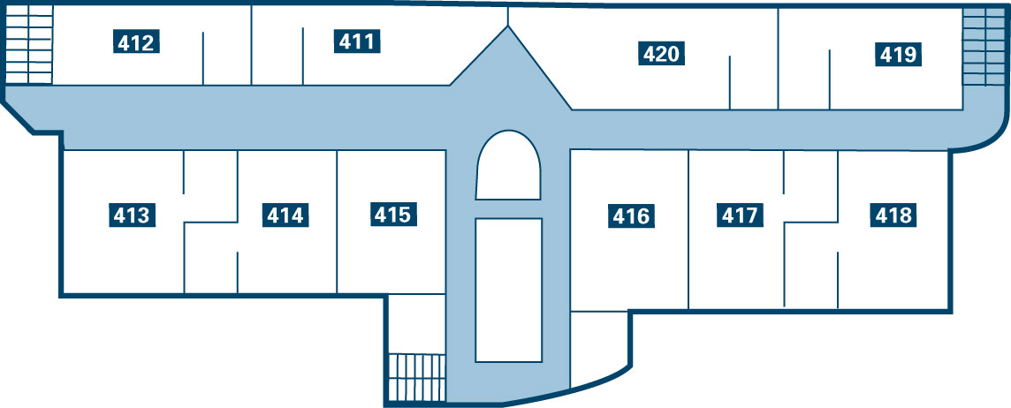
METROHEALTH
Momentum with You in Mind

The new Riverview center’s Cardiac Rehabilitation Program will provide comprehensive education and supervised exercise for cardiovascular patients.

METROHEALTH OFFERS
Cardiac Rehabilitation
Preventative Health Program
Diabetes SEARCH Program
Award-winning Doctors
Children’s Hospital
Heart-Health Wing
Easy Appointment Availability
Convenient Pharmacy Hours

Leading the cardiac rehab’s interdisciplinary team will be Dr. Jarrod Thompson, formerly senior cardiologist at Hospital General and a distinguished lecturer in cardiovascular risk factors at State University Medical School.

RIVERVIEW
HEART HEALTH CENTER

Riverview Heart Health Center Opens June 1

Thanks to the generous donations of the following organizations, MetroHealth will be opening the new Cardiac wing on June 1st.
“The Riverview staff will combine experience in many related fields, state-of-the-art technology, and compassion to deliver the kind of care you’ve come to expect from MetroHealth,” Mr. Klaussen explains. “This new facility will get you in the door, but our staff will keep you coming back.”

We encourage you to visit our new wing and meet our expert doctors and staff who are dedicated to helping you manage a healthy heart and healthy lifestyle.

TOURS available daily at 2 pm.
Please call for additional times and information.
1-800-000-0000
DONORS LIST
United Heart Association
+
DIAGNOSTIC EVALUATION group
+
Health for Life
+
metro Lung Association
METRO
HEALTH
Cardiac Rehab:
The Crucial Step

Your heart is in good hands in the Cardiac Rehabilitation Center of our new Riverview Heart Health wing. We understand that rehabilitation begins in the initial moments after heart surgery, and continues in every moment afterward, from physical therapy and stress reduction to prescription maintenance medications, heart-healthy meal planning and supervised exercise tests.
411
412
413
414
415
416
417
418
419
420
CARDIAC WING INDEX
CARDIAC REHABILITATION
DIAGNOSTIC EVALUATION
INTERVENTION ROOM
GENERAL HEALTH + WELLNESS
PHYSICAL THERAPY ROOM
ANTI-COAGULATION THERAPY
EMERGENCY CARDIAC ROOM
FAMILY SUITE
FAMILY SUITE
CAFE & LOUNGE AREA

