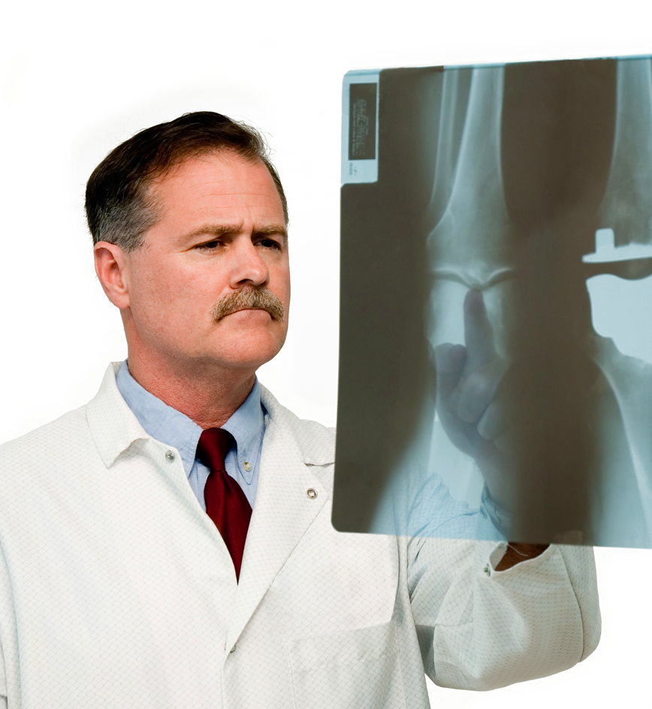


METRO
HEALTH
HOUSE CALLS
A MONTHLY NEWSLETTER FROM METROHEALTH • MAY


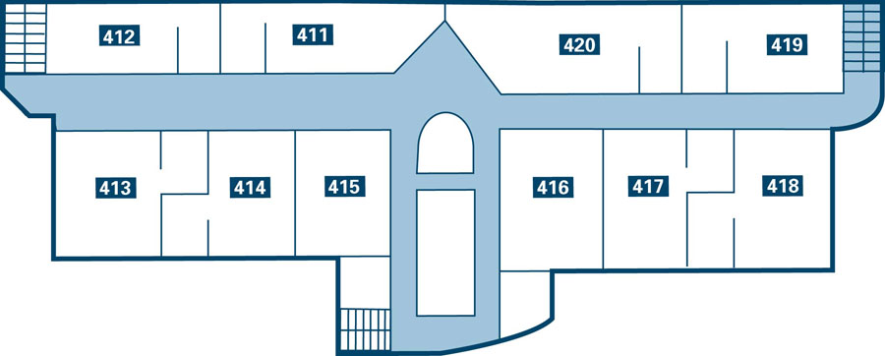

In this issue
+ Riverview Heart Health Center
+ Cardiac Rehabilitation
+ Diabetes SEARCH
+ Children and Diabetes
+ Crash Course in Cholesterol
+ Walking Power
+ House Calls Profile: Dr. Slotkin
+ Speakers Bureau
+ MetroHealth wins NAPA Award
Riverview
Heart Health Center Opens June 1

The MetroHealth Foundation is proud to announce the June 1 opening of the Riverview Heart Health Center, the
latest addition to our main facility, MetroHealth
One. The Riverview center is dedicated to providing the best possible cardiac and cardiac rehabilitation care – and to educating the public about heart health before drastic care is needed.

“Heart care means more than just treating the heart,” MetroHealth CEO Mitch Klaussen says. “It also means caring for you. We humans are marvelously complicated and integrated systems. At the Riverview Heart Health Center, we’ll help you build a healthy life that combines physical activity, diet, and wellness education. And, when it’s needed, we’ll offer our patients world-class medical intervention.”
House Calls Profile #82 Marcus Serilias, M.D.

Specialty Internal medicine
Medical Education
New York Medical College, 1988
Residency
University of Wisconsin at Madison, 1988
Internship
University of Wisconsin at Madison, 1991
Professional Activities and Awards
Section Head of General Internal Medicine, Abbott Northwestern Hospital, Minneapolis
Board Certifications
American Board of Internal Medicine, 1993
Joined MetroHealth 2000
Dr. Serilias on his specialty “Internal medicine touches every aspect of a person’s life and a patient’s care, from health maintenance to chronic and acute illness care.”
On MetroHealth “MetroHealth’s strength is in our numbers. We’re a large, diverse team of professionals with a wealth of resources behind us – but we’re still committed to providing personalized service.”
MetroHealth Pharmacists Recognized
for Excellence
MetroHealth’s pharmacy staff has received the Award for Excellence in Medication Safety. The award, given annually by the North American Pharmacists Association (NAPA), recognizes pharmacy professionals who work with their customers to make the best and safest use of their medicines.
NAPA represents more than 60,000 pharmacists across the US and Canada. About half practice in health-care systems. “Receiving this award means so much to us here at MetroHealth,” says Dr. Jack Polansky, MetroHealth Pharmacy Director.
Speakers Bureau
The MetroHealth Speakers Bureau provides experts in their field to community groups with the aim of educating the larger community on ways to create and maintain a healthy and happy lifestyle. Our speakers are physicians, nurses, and professional staff from all MetroHealth branches who are eager to share their expertise.

If your organization has specific health-care requests on topics not on this list, we will make every effort to match your request with a qualified speaker.

To find out more or to arrange for a speaker to appear before your group,
contact Rick Burleson at the MetroHealth Public Affairs Office. Please make your request at least 8-10 weeks before the
date of your event. Speakers available
on a first-come, first-serve basis.

FOR MORE INFORMATION

MetroHealth offers services and answers to all your health needs. Our goal is to make your visit a positive experience. Visit us at www.metrohealth.com. Or call and speak to one of our helpful staff members at 1-800-000-0000.

NAPA
AWARD for
EXCELLENCE in
MEDICATION
SAFETY
METRO
HEALTH
Cardiac Rehab:
The Crucial Step
The Riverview Cardiac Rehabilitation Program will provide comprehensive education and supervised exercise for cardiovascular patients. Leading the cardiac rehab’s interdisciplinary team will be Dr. Jarrod Thompson, formerly senior cardiologist at Baltimore City General and a distinguished lecturer in cardiovascular risk factors at Harvard Medical School.
Dr. Thompson graduated from the University of California at Berkeley with a BA in biology. He earned his MD at the University of Michigan.
He is best known as the host of the acclaimed PBS series Your Heart and How to Heal It.
House Calls is the monthly newsletter of MetroHealth, a coalition of 1,200 doctors and health-care professionals representing all specialties in five locations. House Calls contents are © The MetroHealth Foundation. All rights reserved. MetroHealth: Your life. Your health. Our help.
The Riverview center will feature the full range of services you would expect in a facility devoted to heart health, including cardiac rehabilitation (see sidebar), emergency cardiac services, diagnostic and interventional cardiology services, anti-coagulation services, and physical therapy. The center will also offer non-traditional programs including stress management, heart-healthy eating, mind/body balance, and training in changing destructive behaviors, managing blood pressure, and taking responsibility for your own health.

“The Riverview staff will combine experience in many related fields, state-of-the-art technology, and compassion to deliver the kind of care you’ve come to expect from MetroHealth,” Mr. Klaussen explains. “This new facility will get you in the door, but our staff will keep you coming back.”
Our speakers offer wide-ranging,
up-to-the-minute information in
the following areas:

ARTHRITIS
Behavioral health
CANCER CARE
GENERAL HEALTH + WELLNESS
GERONTOLOGY
HEART health
HOME CARE SERVICES
HOSPICE SERVICES
IMMUNIZATIONS
INJURY PREVENTION / TRAUMA
MEN’S HEALTH
ORTHOPEDICS
PRESCRIPTION DRUG COVERAGE
SMOKING CESSATION
WOMEN’S HEALTH





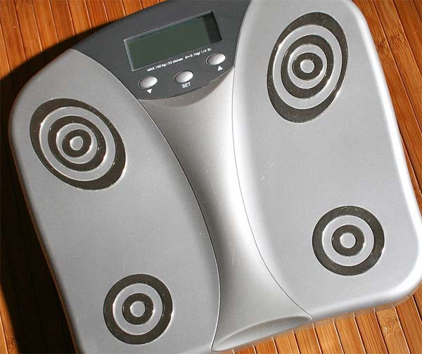
METRO
HEALTH
Diabetes SEARCH Comes to MetroHealth

MetroHealth has been chosen as one
of the 17 regional medical centers involved in SEARCH for Diabetes in Youth, a national study funded by the CDC (Center for Disease Control and Prevention) and NIDDK (National Institute of Diabetes and Digestive
and Kidney Diseases).

Diabetes is a major health concern affecting about 16 million Americans. The SEARCH study will investigate diabetes in children, especially the less-common Type 2 diabetes. Data from children who participate in the study will help medical professionals better understand the complications of diabetes in children. It will also help measure the effectiveness of the treatment these children receive.
If you would like to enroll your child in
the SEARCH study, please contact Chad A. Kinney, RN, MSN, CNP, MetroHealth’s Project Coordinator for the SEARCH study, at MetroHealth One. Participation involves an interview, a physical exam,
and a follow-up exam one year later. All results will be provided to you and your family doctor.

“Medical knowledge can only advance if people are willing to participate in these studies,” says Kinney. “We want to beat diabetes, and there’s still so much we don’t know about the disease in our children.”

All of the information given by SEARCH participants will be held in strict confidence and used for research purposes only.
FOR MORE INFORMATION
Fast Facts on Children and Diabetes in the US
You can learn more about
the SEARCH study at www.SEARCHforDIABETES.org

The Juvenile Diabetes Research Foundation International can be found at www.jdrf.org

To order a free copy of the CDC
book Take Charge of Your Diabetes, call 1-877-000-0000 or go to www.cdc.gov/diabetes/
pubs/tcyd/ktrack.htm
+
+
+
- One in every 400-600 children and adolescents have Type 1 Diabetes.
- 57% of children and adolescents with Type 1 diabetes have a close family member with diabetes (sibling, parent, or grandparent). This number increases to 84% for young people with Type 2 diabetes.
- Data on Type 2 diabetes is incomplete, but reports from clinics around the country indicate that this type of disease is increasingly appearing in children from American Indian, African-American, and Hispanic/Latino America backgrounds.
- Approximately 175,000 children and adolescents (younger than 20) have diabetes.
- 20% also have elevated levels of cholesterol.
Source: National Diabetes Information Clearinghouse (NDIC)
via high-density lipoproteins (HDL) and low-density lipoproteins (LDL). Our bodies make all the cholesterol we need; we take in more from the foods we eat. Our cholesterol levels are determined by many factors, including family medical history, Body Mass Index, exercise vs. inactivity, and diet.

LDL far outnumbers HDL. We need LDL, but too much can be harmful. High LDL cholesterol levels in your bloodstream increase your vulnerability to heart disease.
Guest Editorial: Crash Course in Cholesterol
Research Nurse, MetroHealth One
By Judy Gould, RN, BSN,

We hear the word “cholesterol” a lot these days, and its reputation is not good. But cholesterol by itself is not a bad thing. Cholesterol is a waxy substance found in every cell of the body. It helps to hold the cells together and helps the body digest fats. Cholesterol is transported around the body
When combined with other substances, LDL forms plaque, which sticks to the walls of arteries and narrows them. If these fatty plaques burst, clots form to seal them, further restricting blood flow and leaving us vulnerable to heart attack or stroke.

HDL is the Mr. Clean of the bloodstream. Its main job is to mop up harmful fats and transport them to the liver for removal from the body. HDL also helps to prevent clots by keeping the platelets in the blood from getting too sticky. Unlike LDL, high levels of HDL in the blood are beneficial.
Step right up! Using Pedometers to Boost Your Walking Power
Let’s go shopping
When choosing a pedometer, look for a display monitor you can read under bright sunlight or at dawn or twilight. Make sure it’s lightweight and that it fits comfortably on your clothing and won’t fall off if you put on some speed.

Choose your goals
Begin your goal-setting by finding a baseline measurement. Your pedometer’s instructions will explain how to set the device’s brain to measure your particular stride. Once you’ve set that, wear your pedometer all day for three days. Add each day’s total together and divide by three. That’s your baseline.

Achieving small goals along the way can help motivate you and keep you walking. For example, your first short-term goal might be to double your baseline steps. Your long-term goal might be to walk the 10,000 steps a day – about 5 miles on level ground – recommended by the President’s Council on Physical Fitness and Sports. Another long-term goal might be to walk continuously for 30 minutes (about 4,000 steps) every day.
Now stretch those goals
Once you’ve hit your first targets, aim higher – gradually. Start by adding 200 to 1,000 steps a day to your baseline, depending on your fitness and energy levels. If you’re just starting a walking program, and especially if you’ve been inactive for a long period, push yourself gently. For example, increase your baseline by 10 percent each week.

You’ll eventually find yourself looking for opportunities to walk short distances at home or at work. You’ll find yourself parking your car at the far end of the parking lot from your office, or taking a bus to work (and piling up those steps to and from the bus stop). At home, you’d be surprised how many steps it takes to do the laundry or the shopping, or to walk across a mall rather than park closest to the store you want. The more steps you can accumulate
throughout the
day, the better!
By Sherri Tang, ATC, Physical Medicine and Rehabilitation, MetroHealth One

We’re often asked by our clients, “What’s the best exercise I can do?” Our answer is always the same: “The best exercise you can do is the one you’ll actually do.”

If you feel you have so little time to exercise that you can only do one thing, and if you’re wondering what that thing should be, try walking. You’re already doing it! You can walk almost anywhere, at any time, and you don’t need a lot of high-tech, high-cost gear to get off on the right foot. Except one thing: a pedometer.

A pedometer is inexpensive and simple to use. You can get pedometers that tell you how many calories you’ve burned and how far you’ve traveled, but all you really need is the pedometer’s main function: To count your steps. A pedometer will prove to you that even small steps (if you take enough of them!) lead to better health.
Diet and exercise are crucial to managing cholesterol. Start by limiting the saturated fat and cholesterol in your diet. Common sources of saturated fat and cholesterol include red meat, whole milk, ice cream, and eggs. Eat these foods less often, eat smaller amounts, or choose alternatives (such as chicken, low-fat milk, or frozen yogurt).

Healthy Cooking with Hannah, a collection of fun, healthy recipes from MetroHealth’s head chef, Hannah K. Davies, is available at all MetroHealth facilities at no charge to you. Chef Davies also
teaches a class based on her book – check with the MetroHealth nearest you for her next appearance there. And don’t overlook a membership at your local fitness center or YMCA!

The National Heart, Lung and Blood Institute offers detailed information about cholesterol. Visit them at www.nhlbi.nih.gov/health/dci/. Select High Blood Cholesterol under the Browse tab.
FOR MORE INFORMATION

