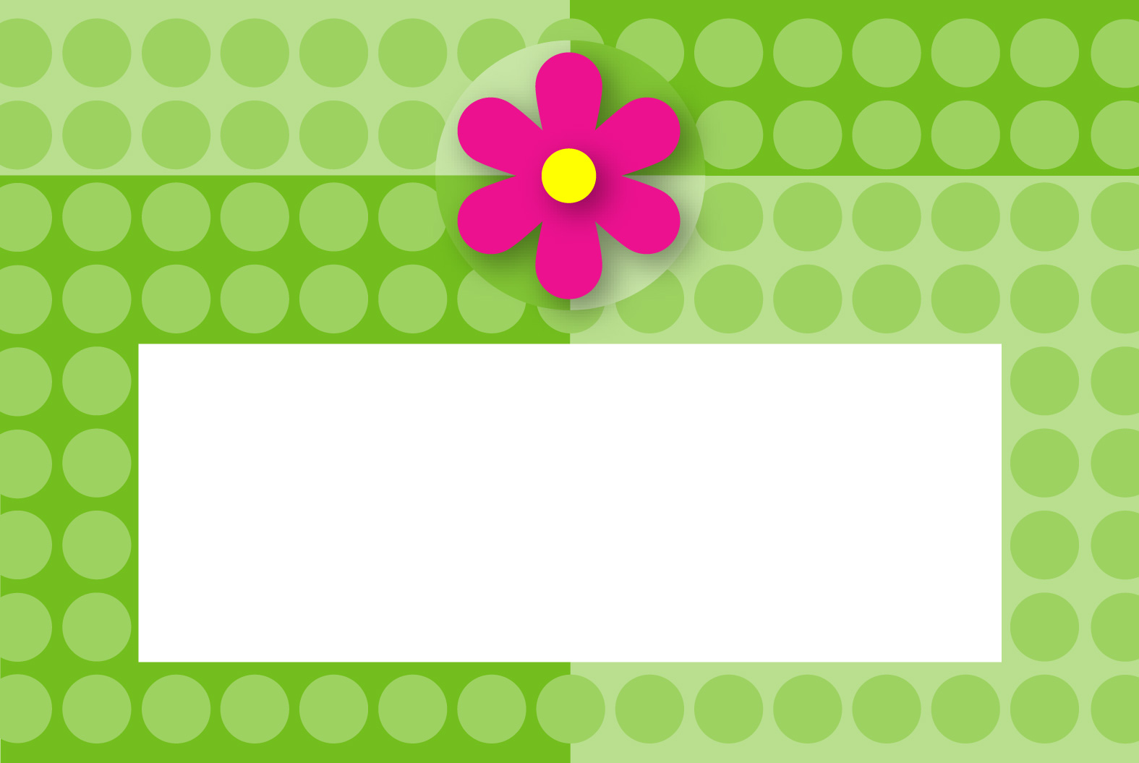
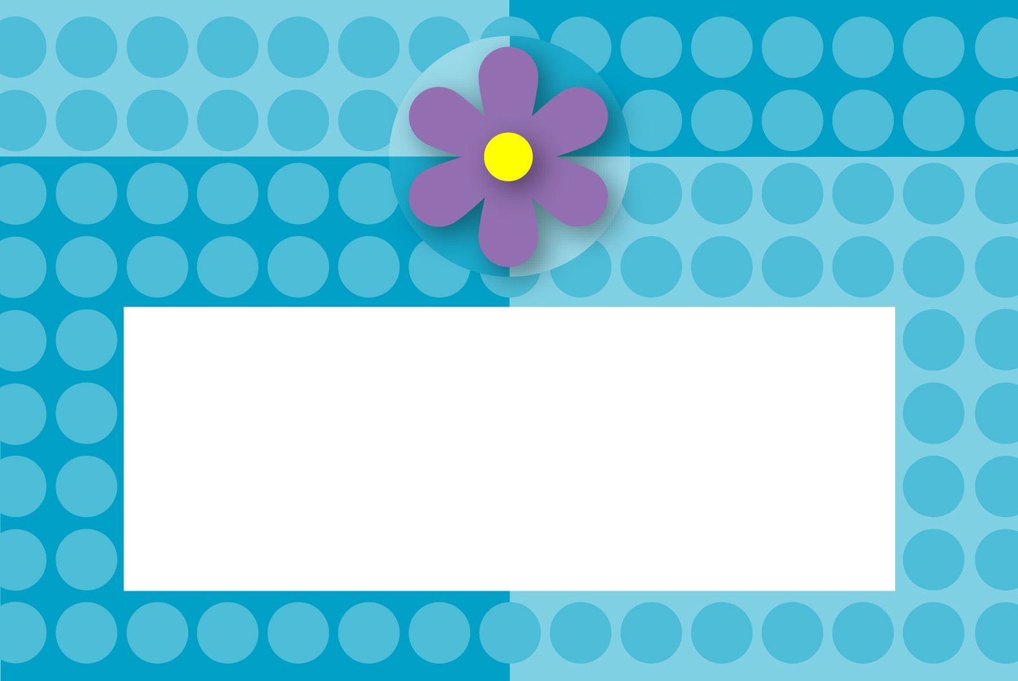
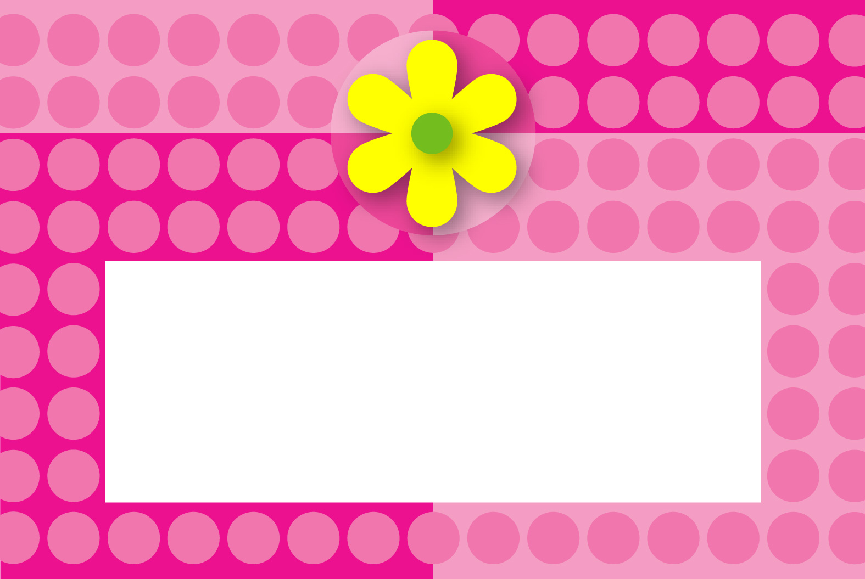
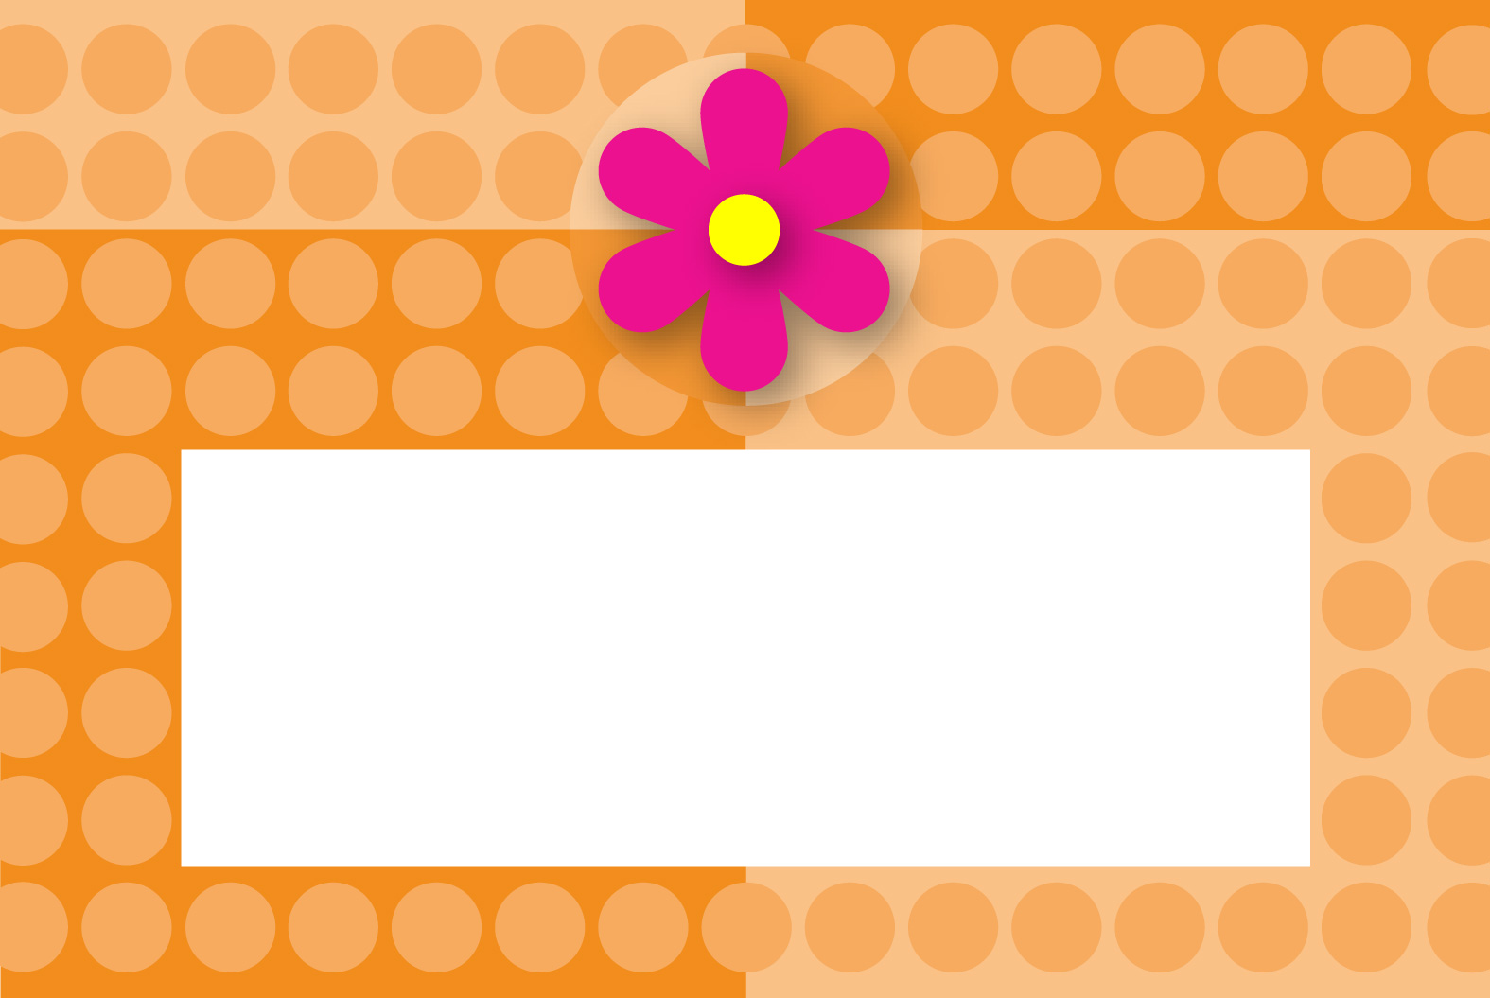





It’s Conference Time!

YOUR APPOINTMENT IS SCHEDULED FOR:

October 28th at 2 pm
Room 7, Miss Smith
I look forward to meeting with you.

Please call with any questions or to re-schedule.

Office: 000-000-0000
Room 7: 000-000-0000

It’s Conference Time!

YOUR APPOINTMENT IS SCHEDULED FOR:

October 28th at 2 pm
Room 7, Miss Smith
I look forward to meeting with you.

Please call with any questions or to re-schedule.

Office: 000-000-0000
Room 7: 000-000-0000

It’s Conference Time!

YOUR APPOINTMENT IS SCHEDULED FOR:

October 28th at 2 pm
Room 7, Miss Smith
I look forward to meeting with you.

Please call with any questions or to re-schedule.

Office: 000-000-0000
Room 7: 000-000-0000

It’s Conference Time!

YOUR APPOINTMENT IS SCHEDULED FOR:

October 28th at 2 pm
Room 7, Miss Smith
I look forward to meeting with you.

Please call with any questions or to re-schedule.

Office: 000-000-0000
Room 7: 000-000-0000

